Screen 1 – OTP screen-

Send One-Time Passcode – Address

For your security, we’ll send a one-time passcode to your registered email address.

Click the button below to send the pass-code. It’s valid for 10 minutes.

If you don’t receive your passcode within a few minutes, please check your spam folder or request a new one.

Submit One-Time Passcode – Address

Enter your one-time passcode in the box below to access your tenancy review.

Enter Passcode

Need help? Respond to your tenancy review email with any issues and the team will be happy to help.

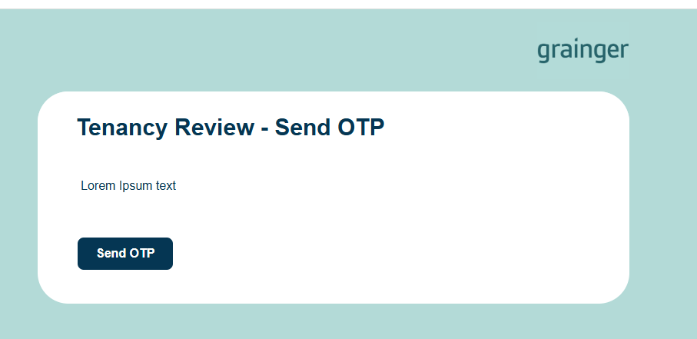
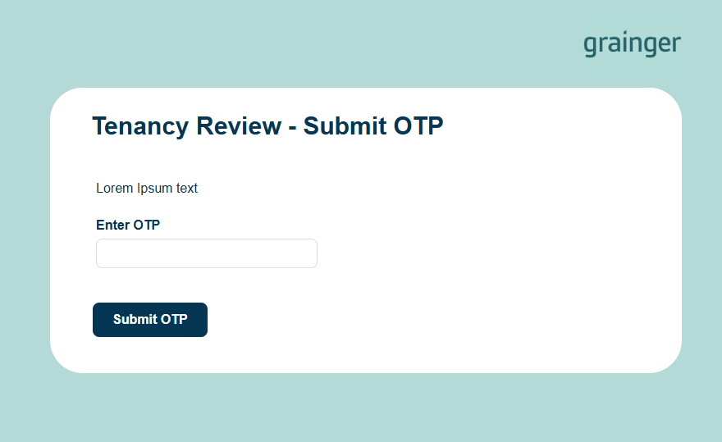

Screen 2
Tenancy Review – Address- Month?

It’s time to review your tenancy for the year ahead.

You can see the details of your tenancy review and respond via the options below.

Property:
Current Monthly Rent:
New Monthly Rent:
Rent Review Date:
If Applicable:
Break Clause:
Tenancy Length (months):

Box to include message from Tenancy Review Co-ordinator – to potentially include comparables or messages.

- I’m happy with these terms | - I’ve got some questions

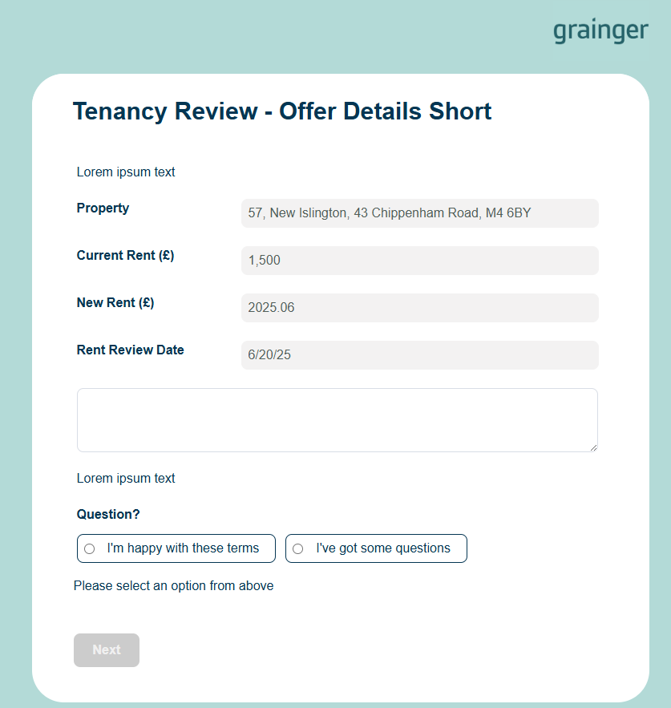

Screen 3
Tenancy Review – Contact us

Query or Request

In the Box:

Please write your question or request below and our team will get back to you as soon as possible.
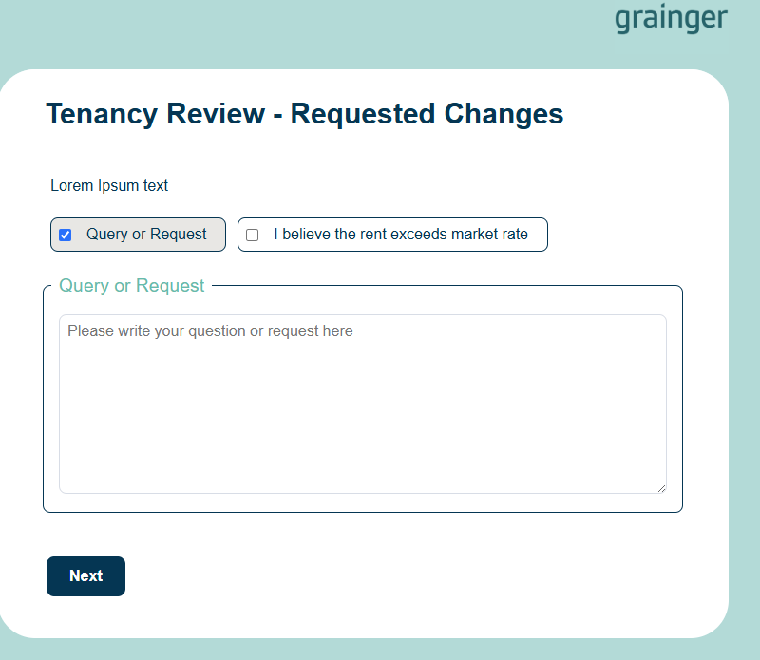

Screen 4
I believe the rent exceeds market rate.

We’re sorry to hear this, we really have researched this carefully. Please submit your counter offer with your supporting evidence for us to consider.

- Submit your counter offer:
Let us know the rent amount you feel is fair and reflective of the current market.
- Provide supporting evidence:
Please include details of similar homes that are currently available, ideally with links to live listings. The properties should be directly comparable, within the immediate vicinity of your home and available within a similar timeframe to your rent review date.

In the box
Please provide evidence including links to relevant listings where possible.

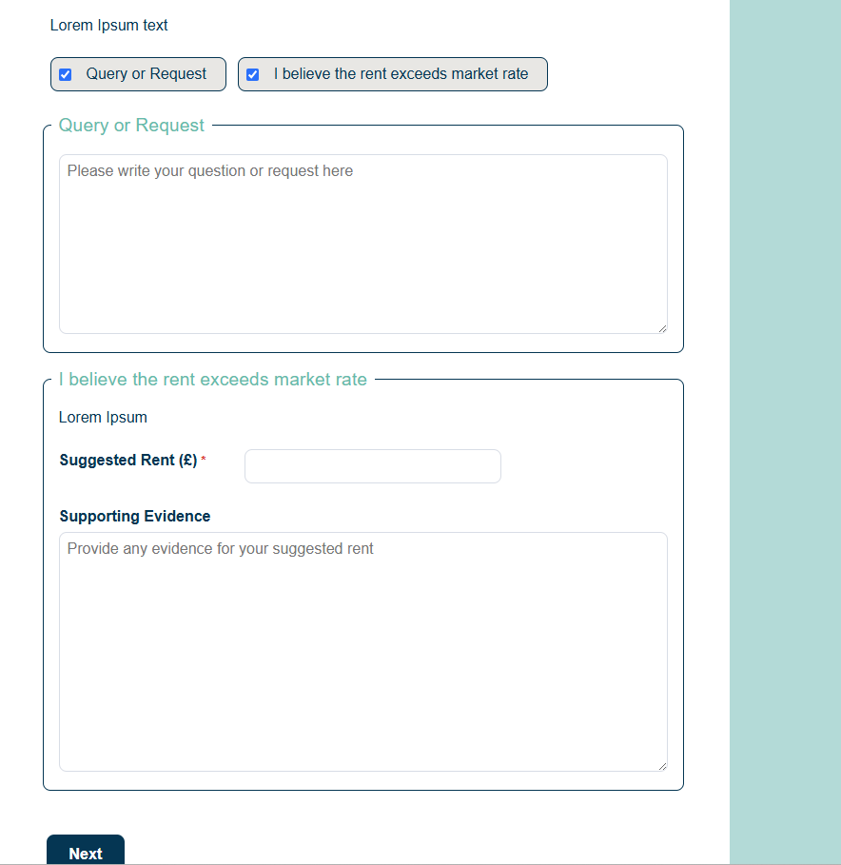

Screen 5 – from either route.
Thank you for submitting your response.

